CREATE TABLE MANUFACTURER

(

Mfname VARCHAR(20) PRIMARY KEY,

City VARCHAR(20),

State VARCHAR(20)

)

CREATE TABLE EMPLOYEE

(

EmployeeID INT PRIMARY KEY,

EmpName VARCHAR(20),

Area_code VARCHAR(20),

Phone VARCHAR(10),

Email VARCHAR(25)

)

CREATE TABLE COMPUTER(

SerialNumber INT PRIMARY KEY,

Mfname VARCHAR(20),

Model VARCHAR(20),

Weight DECIMAL(4,2),

EmployeeID INT,

CONSTRAINT fk_mfname FOREIGN KEY(Mfname) REFERENCES

MANUFACTURER(Mfname),

CONSTRAINT fk_empid FOREIGN KEY(EmployeeID) REFERENCES

EMPLOYEE(EmployeeID)

)

INSERT INTO Manufacturer (MfName, city, state)

VALUES

('Akhil', 'south dakota', 'africa'),

('Rahul', 'kollam', 'kerala'),

('Ravi', 'kochi', 'kerala');

INSERT INTO Computer (SerialNumber, Model, weight, EmployeeId, MfName)

VALUES

(101, 'Model1', 12.5, 1, 'Akhil'),

(102, 'Model2', 28.2, 2, 'Rahul'),

(103, 'Model3', 13.7, 3, 'Ravi');

INSERT INTO Employee (EmployeeId, EmpName, area_code, phone, email)

VALUES

(1, 'Joseph', '505', '9987675423', 'joseph@gmail.com'),

(2, 'Jake', '206', '9876456342', 'jake@gmail.com'),

(3, 'Adam', '345', '9364536789', 'adam@gmail.com');

--Q1

SELECT MfName

FROM Manufacturer

WHERE city = 'South Dakota';

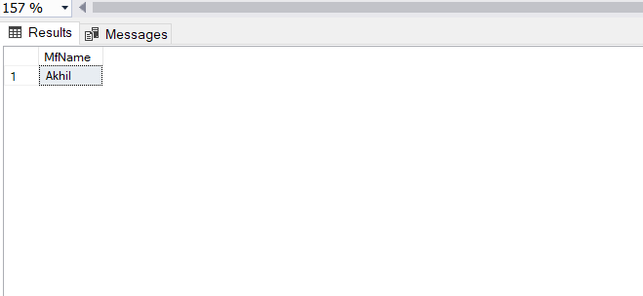

--Q2

SELECT AVG(Weight)AS 'average weight' FROM COMPUTER;

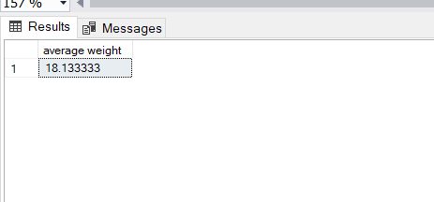

--Q3

SELECT EmpName FROM EMPLOYEE WHERE Area_Code LIKE '2%';

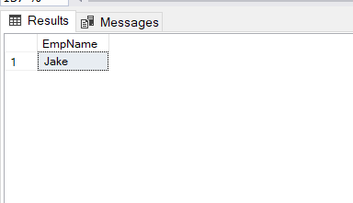

--Q4

SELECT SerialNumber

FROM Computer

WHERE weight < (SELECT AVG(weight) FROM Computer);

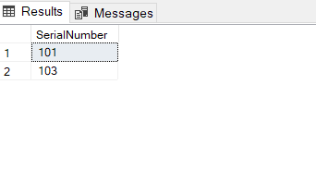

--Q5

SELECT MfName FROM MANUFACTURER WHERE MfName NOT IN (SELECT MfName FROM COMPUTER)

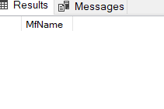

--Q6

SELECT e.EmpName, c.SerialNumber, m.city FROM EMPLOYEE e

JOIN COMPUTER c ON e.EmployeeID = c.EmployeeID

JOIN MANUFACTURER m ON c.MfName = m.MfName

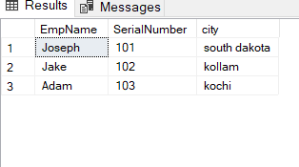

--Q7

create procedure getDetails

@EmployeeId int

as

begin

select Computer.SerialNumber, Manufacturer.mfname, Model, weight

from computer

join employee on Computer.EmployeeId = Employee.EmployeeId

join manufacturer on Computer.MfName = Manufacturer.MfName

WHERE Employee.EmployeeId =@EmployeeId;

END;

exec getDetails @employeeid=3

